**Ansible**

**Ansible Installation**

1. Setup EC2 instance
2. Setup hostname
3. Create ansadmin
4. Add ansadmin to sudoer file
5. Generate ssh key
6. Enable passwordless based login
7. Install ansible
8. Setup EC2 instance

Create ec2 instnace with Linux

Login in it with putty , where user is ec2-user

1. Change to root user

Sudo su –

Change the hostname

Vi /etc/hosts

#Add

Ansible-server

1. Create ansadmin

useradd ansadmin

Setup password

Passwd ansadmin

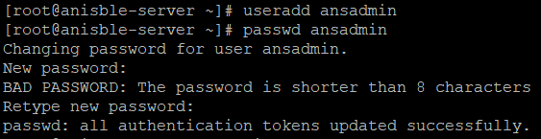

1. Add ansadmin to sudoer file

vi /etc/sudoer

Go in the end and search for “##Same thing without a password” and add line 🡪 ansadmin ALL=(ALL) NOPASSWD: ALL

e.g.



## Same thing without a password

# %wheel ALL=(ALL) NOPASSWD: ALL

ansadmin ALL=(ALL) NOPASSWD: ALL

1. Generate ssh key for passwordless authentication

Edit sshd_config file uncomment PasswordAuthentication yes means remove the # from that line and comment the PasswordAuthentication no means put # in front of that line see below example. After that reload the service so that changes get reflect for that use command service sshd reload.

vi /etc/ssh/sshd_config

service sshd reload



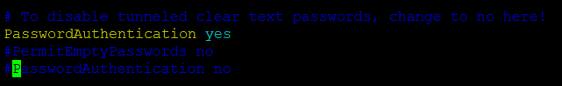

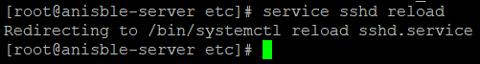

Now open the putty and try to login to ec2 instance with new created user i.e. ansadmin and password which you have provided. But remember if you are trying to login with new user you don’t have to give private key because we have updated the file sshd to use passwordless authentication.

Steps are as follow

Open putty

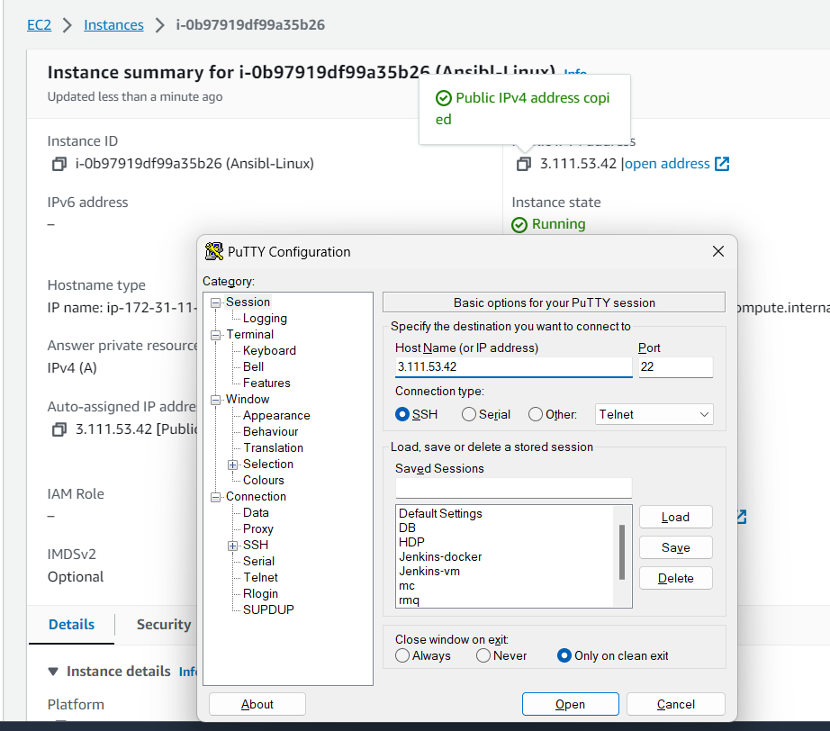

Click on open and login with ansadmin and password

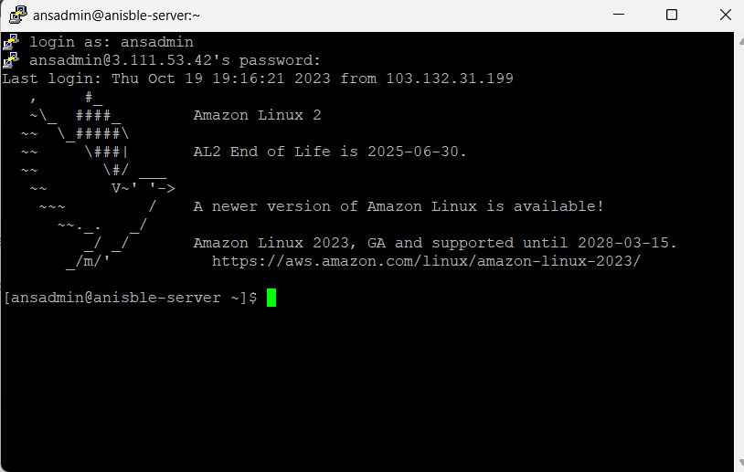

Now create the ssh key using command ssh-keygen just enter don’t put any value.

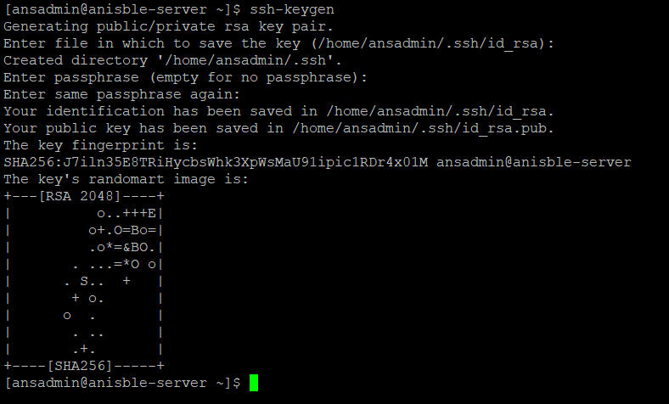

It will create keys in /home/ansadmin/.ssh directory. These keys are responsible for accessing different machine(ec2 instance). Id_rsa is private key and id_rsa.pub is public key, now whenever you want to access other machine from this machine you have to copy its id_rsa.pub key in other machine .ssh folder(/home/<user>/.ssh/).

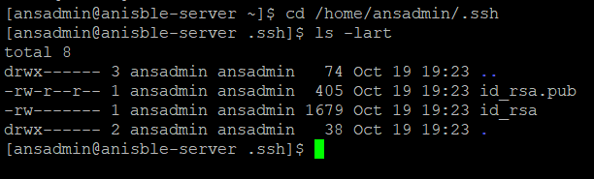

1. To Install ansible using command there are two ways
   1. using below command

amazon-linux-extras install ansible

6.2. Using below commands

yum install epel-release

amazon-linux-extras install epel

yum repolist

yum install ansible

By default it will download python because ansible needs python. Check the versions whether ansible and python got installed or not.

python –version

ansible --version

